PAPER LENGTH is 10 (ten) pages plus References
 | POAC’25  St. John’s, Newfoundland and Labrador, Canada | Proceedings of the 28th International Conference on  Port and Ocean Engineering under Arctic Conditions  Jul 13-17, 2025  St. John’s, Newfoundland and Labrador  Canada

Title of your paper
(Times New Roman, Black, Bold, 16 point, Centered)

First author¹, second author², third author² (First name + Middle initial + Last name)
¹ Affiliation of first author(s) (Institution, City, Country)
² Affiliation of co-author(s) (Institution, City, Country) (Times New Roman, 12 point, left)

ABSTRACT (Capital, Times New Roman, Bold, 12 point, left)
Word count for abstract is 100 ~ 250. The abstract should be concise and compact. (Times New Roman, 12 point, justified).

KEY WORDS (Times New Roman, Capital, 12 point, left): up to 5 key words. Start with capital and separate each key word with a semicolon. Ex) Ice; Failure; Icebreaker. (Times New Roman, 12 point, justified)

NOMENCLATURE (Optional, Times New Roman, Capital, 12 point, left)
Text. (Times New Roman, 12 point, left)

SECTION LEVEL #1 (Times New Roman, Capital, Bold, 12 point, left)
The paragraph format recommended for your paper is illustrated in Figure 1. Please note that no pagination is required.
For in-text citations and references, if possible, use Harvard’s short reference system for citations in the text. For example, ‘'Hamel (2000) suggests...’' or ‘'Choi and Nam (2005) found that...’' or ‘'A study of economic change (Nelson, et al., 1982) has shown that ……’. (Times New Roman, 12 point, justified)

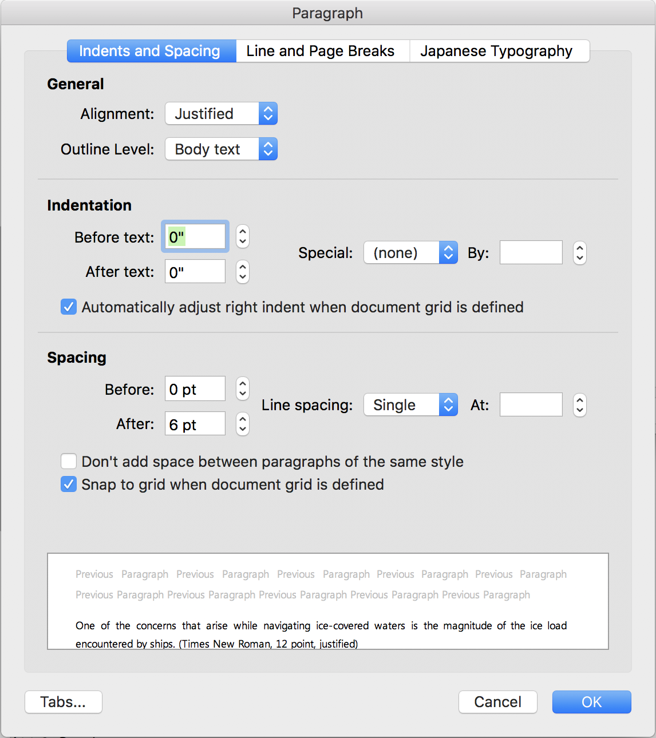
Figure 1. Recommended format for paragraphs (Times New Roman, 12 point, centered)

Section Level #2 (Times New Roman, Bold, 12 point, left)
Footnotes should be avoided, if possible. Instead, it is preferred that any brief note be placed in numerical order following the (alphabetically arranged) reference list. Only published works should be referenced.
Table 1. Data events during general ice transits (Times New Roman, 12 point, centered)
Data file No. | Date | Time (UTC) | Measuring time (s) | No. of events
01 | 2012. 02. 10 | 19:00 ~ 19:10 | 600 | 7
02 | 2012. 02. 10 | 19:15 ~ 19:45 | 1,800 | 11
03 | 2012. 02. 10 | 20:50 ~ 21:20 | 1,800 | 44
04 | 2012. 02. 20 | 00:45 ~ 01:15 | 2,700 | 7
06 | 2012. 02. 27 | 11:00 ~ 11:30 | 4,900 | 56
07 | 2012. 02. 27 | 02:10 ~ 03:30 | 5,100 | 45

[MN] (1)
(Equation: Times New Roman, 12 point, equation – left justified, equation number – right justified. Any equation editor can be used.)
CONCLUSIONS (Times New Roman, Capital, Bold, 12 point, left)
Short summary for your result here. (Times New Roman, 12 point, justified)

ACKNOWLEDGEMENTS (Times New Roman, Capital, Bold, 12 point, left)
Optional (Times New Roman, 12 point, justified)

REFERENCES (Times New Roman, Capital, Bold, 12 point, left)
All references should be prepared in English and arranged in alphabetical order. The reference list should reflect all the citations from the body text, and the references cited in the body text should appear in the reference list. The author-date format such as the Harvard reference system is recommended. Some examples are shown in the below.

[Journal articles]
Nam, J.H., Sohn, S., & Singer, D.J., 2012. Estimation of geometry-based manufacturing cost of complex offshore structures in early design stage. International Journal of Naval Architecture and Ocean Engineering, 4(3), pp.291-301.
[Conference articles]
Naude, P. & Holland, C., 1998. Marketing in the information domain. In: Halinen-Kaila, A. and Nummela, N. eds., Interaction, Relationships and Networks: Visions for the Future, Proceedings of the 14th Annual IMP Conference, pp.245-262.
[Books]
Farouki, R.T., 2008. Pythagorean – Hodograph Curves. Springer-Verlag:Berlin.
[Dissertations]
Jackson, A., 2009. New technology for innovative ship design: a case study of the warship. Ph.D. Cambridge: Massachusetts Institute of Technology.
[Online publication]
The Society of Naval Architects of Korea, 2001. How to prepare a SNAK journal paper? [Online] (Updated 1 August 2010) Available at: http://www.snak.or.kr [Accessed 17 July 2010].
[Reports]
Department for Trade and Industry (DTI), 2002. White Paper on Enterprise, Skills and Innovation, London: DTI.

